Before Setting Width:  
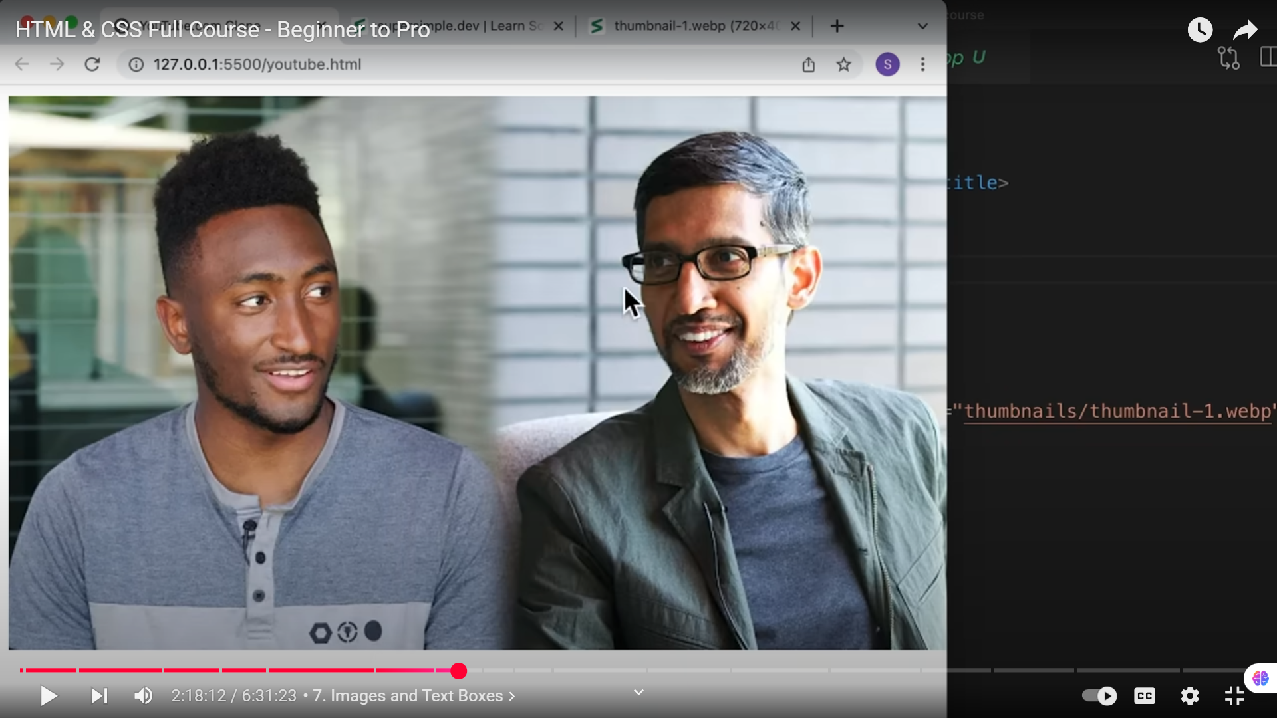  
  
After Setting Width:  
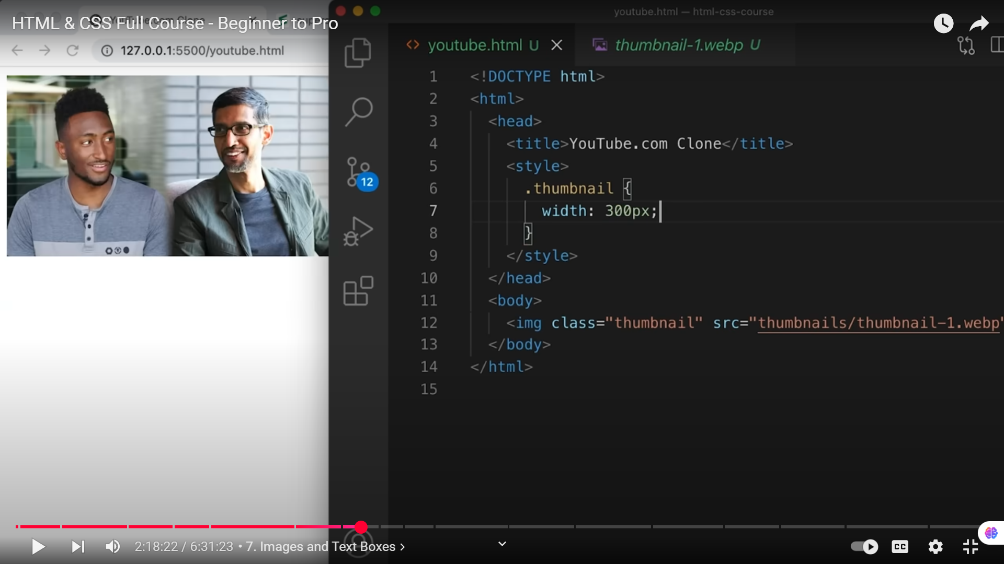  
**WHEN WIDTH IS CHANGED, HEIGHT ALSO CHANGES!!!!!!!!!!!!!!!!!!!!!!!!!!!!!!!!**

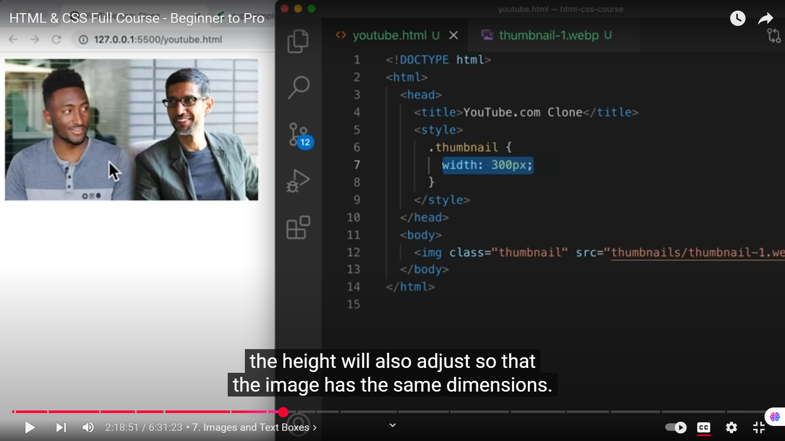

**NOW IF WE CHANGE THE HEIGHT EXPLICITLY, THIS WILL CAUSE THE IMAGE TO LOOSE ITS SHAPE**